GL PRO 12050

Resources for promoting GLPro (US, AU, CA, UK) ($150.00 CPA)
Use these to quickstart your campaigns.

Your affiliate link is
https://maxwebconnect.com/12050/7446/3/?

Product name | Conversion rate | Product price | Average payout | Earnings per click | Trending
GL Pro | 2.45% | $79 | $150 | $3.94 | 26.75

Below is a collection of links customized to your account.
All sales generated from these links will be automatically credited to you.
- GLPro (US, AU, CA, UK) ($150.00 CPA)
Restrictions: No SMS, No Brand Bidding, No PPC, No Spam
https://mwebscout.com/12050/7446/3/?
- GLPro TSL (US, AU, CA, UK) ($150.00 CPA)
Restrictions: No SMS, No Brand Bidding, No PPC, No Spam
https://mwebscout.com/12050/7446/7/?
Pro Tip:
You can add &subid=SOMETHING to the link, replacing "SOMETHING" with a short text identifying your traffic source. This will make it easier to track your performance across different marketing campaigns.

Email Swipe #1
Subject Line
Breaking: Hidden Parasite Destroying Your Pancreas (And How to Stop It)
Body:
Hello [NAME],
Did you know that every 17 seconds someone in America is diagnosed with type 2 diabetes?
And every 7 seconds, another person dies from its deadly complications.
But here’s the breakthrough that changes everything…
Dr. Robert Stevens — a board-certified endocrinologist and senior researcher with studies connected to Johns Hopkins and Cambridge — has uncovered the real cause of diabetes:
A hidden parasite called Eurytrema pancreaticum that silently attacks your pancreas, feeding on insulin and destroying the cells that keep your blood sugar stable.
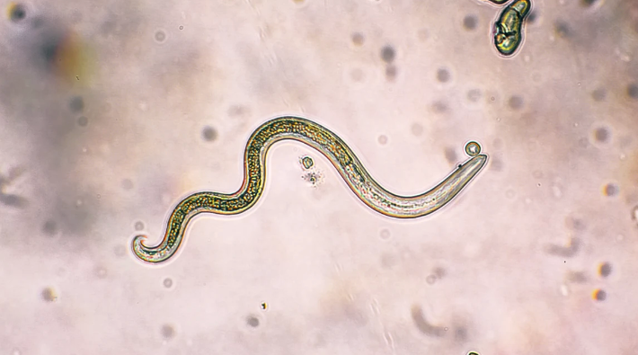
Now that we know the true cause, there’s finally a way to eliminate it.
Dr. Stevens developed a natural protocol called the Glucose Reset Ritual, which kills this parasite and reactivates your body’s natural ability to produce GLP-1 — your built-in blood sugar regulator.
The results?
- Pamela from Texas dropped her glucose from over 300 to 94 in just six weeks.
- Adam from Illinois saw his A1c stabilize at 5.5% and now eats whatever he wants — without fear.
And these are just two of the thousands of success stories.
You’ll be shocked at how simple it is to reverse diabetes once you target the root cause — instead of just masking symptoms with endless meds.
Watch this short presentation while it’s still online:
[Watch The Breakthrough Presentation Now]
Stay healthy,
— Dr. Robert Stevens
P.S. With this natural morning ritual, you can finally enjoy the foods you love without guilt — and without worrying about blood sugar spikes. Don’t miss this life-changing discovery.

Email Swipe #2
Subject Line
What’s REALLY Causing Your Diabetes? (Hint: It’s Not Sugar or Carbs)
Body:
Hello [NAME],
Chances are, no one has ever told you this before.
But recent research from the University of Cambridge — validated by thousands of real patients — has finally cracked the mystery behind type 2 diabetes.
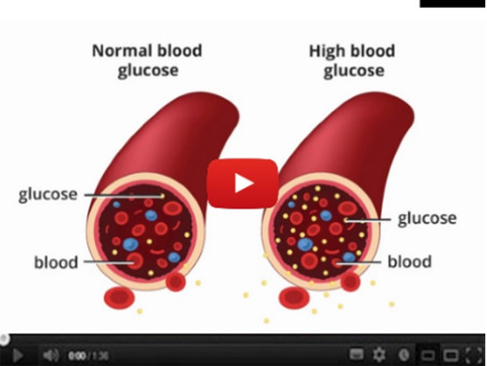
So let me ask you: what do you think the real root cause is?
- Bad genetics
- Poor diet
- High blood sugar
- Or… a hidden parasite in your pancreas?
Most people guess wrong.
That’s why Dr. Robert Stevens — a board-certified endocrinologist and senior researcher — created a short online presentation revealing the truth. Inside, you’ll see how this parasite silently feeds on insulin, blocks your pancreas from producing GLP-1, and keeps your blood sugar stuck high… no matter how strict your diet or how many meds you take.
And more importantly, you’ll discover how to eliminate it — and finally reverse diabetes naturally, in just weeks.
👉 [Watch the short presentation here]
Stay healthy,
— Dr. Robert Stevens
P.S. Once you see how simple this natural method is, you’ll never look at diabetes the same way again. Don’t wait — the video could be taken down at any time.

Email Swipe #3
Subject Line
Natural Formula 8x MORE POWERFUL than Ozempic (Without the Side Effects)
Body:
According to the latest research led by Dr. Robert Stevens with studies tied to Johns Hopkins and Cambridge…
You’re NOT going to find the real solution to blood sugar problems in a drug-filled pharmacy.
(Don’t risk the dangerous side effects of Ozempic or Metformin.)
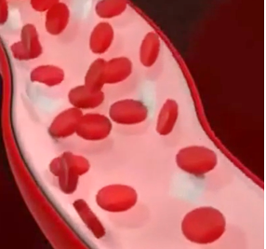
Because the truth is, the safe and natural secret…
…is helping thousands of Americans slash their A1C in weeks —
while also melting away stubborn fat.
Tap below to discover the Glucose Reset Ritual Big Pharma doesn’t want you to see.
⇒ See the TRUE STORY of Pamela from Texas, who dropped her glucose from 300+ to just 94 in 6 weeks — without starving diets or injections.
[Watch The Breakthrough Presentation Now]

Email Swipe #4
Subject Line
Eat as much as you want (your pancreas is under attack)
Body:
Eat as much pizza or pasta as you want, [NAME].
The truth is… Type 2 diabetes isn’t really about carbs or diet.
In fact, studies from Cambridge showed people eating sweets daily — yet keeping perfect blood sugar around 108 after meals.
Why?
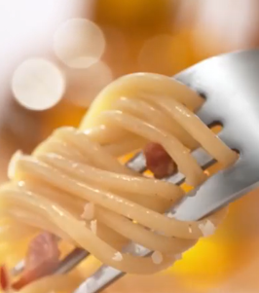
Because the real culprit behind type 2 isn’t sugar… it’s a hidden parasite called Eurytrema pancreaticum that silently infects your pancreas.
This parasite blocks your body’s natural GLP-1 production, destroys insulin-producing cells, and keeps your glucose stuck high — no matter how strict your diet is.
The good news is: Dr. Robert Stevens discovered a natural Glucose Reset Ritual that kills the parasite and restores your body’s natural ability to regulate blood sugar.
But this short video could be taken down at any moment.
👉 [Watch How to Eliminate the Diabetes Parasite Now]
Stay healthy,
— Dr. Robert Stevens

Email Swipe #5
Subject Line
The ONLY diabetes information you'll ever need
Body:
Hi [NAME],
If you've been diagnosed with type-2-diabetes, you're probably up to your eyeballs with diabetes information.
The problem is, you don't know what to make of it!
With thousands of books, articles, and online programs out there, there's no shortage of information…just a shortage of good information.
This discovery by Dr. Yumi Takahashi from Nagano, Japan explains why nothing else has worked for you.
>> Keep reading, because I’m going to give you the only type 2 diabetes information you’ll ever need!
[Discover The Japanese Breakthrough]
Thank you! [RANDOM NAME]

Email Swipe #6
Subject Line
The ONLY diabetes information you’ll ever need
Body:
Hi [NAME],
If you’ve been diagnosed with type 2 diabetes, you’re probably drowning in information.
Books, diets, medications, programs — you’ve tried it all, but nothing really works.
The truth? Most of it is just noise.
That’s why this breakthrough from Dr. Robert Stevens, endocrinologist and senior researcher, is so important.
His discovery — confirmed by studies at Cambridge — reveals the real reason nothing else has worked for you:
A hidden parasite inside your pancreas that blocks your body from producing GLP-1, your natural blood sugar stabilizer.
👉 Keep reading, because this may be the only type 2 diabetes information you’ll ever need.
[Discover The Breakthrough Now]
Thank you! [RANDOM NAME]

Email Swipe #7
Subject Line
[UNCENSORED] U.S. Doctor Exposes Pancreatic Parasite Big Pharma Hides
Body:
Hey [NAME],
Groundbreaking research tied to the University of Cambridge and Johns Hopkins has revealed the real root cause of type 2 diabetes.
It’s not sugar.
It’s not carbs.
And it’s not your genes.
It’s a hidden parasite called Eurytrema pancreaticum that lodges inside your pancreas, feeding on insulin and destroying the cells that regulate blood sugar.
Now here’s the question:
Which natural ingredient do you think targets this parasite at the root — restoring your pancreas and stabilizing your glucose for good?
- Berberine
- Cinnamon Bark Extract
- Alpha Lipoic Acid
- Resveratrol
The answer will shock you — and could change your life.
👉 Watch this short video explanation now.
Yours in good health,
Dr. Robert Stevens
P.S. If you want to learn how this pancreatic parasite wreaks havoc on your body — and how to eliminate it safely — click here before the video disappears.

Email Swipe #8
Subject Line
Confession of a Disgraced Diabetes Doctor
Body:
Confession of a Disgraced Diabetes Doctor:
For over 20 years, I prescribed insulin, Metformin, and now Ozempic — you name it. I followed every conventional protocol to the letter.
But here’s the truth I never told my patients…
None of it worked long-term. Blood sugar would spike out of control. Medications stopped working. Complications — amputations, blindness, heart attacks — became inevitable.
Everything changed after a shocking discovery linked to research out of Cambridge.
Scientists uncovered the true cause of type 2 diabetes — a hidden parasite called Eurytrema pancreaticum that infects your pancreas. This parasite feeds on insulin, destroys the beta cells that produce GLP-1, and makes your body resistant — no matter how healthy your diet is.
I tested a natural formula designed to kill this parasite and restore GLP-1 production. The results were immediate.
When my wife Sarah took it, her blood sugar plummeted from dangerous highs to 95 in just weeks. Her fatigue vanished, the tingling in her hands disappeared, and she finally got her life back.
The secret? A natural protocol I now call the Glucose Reset Ritual — a blend of ultra-purified herbs and compounds that create an environment where the parasite cannot survive, allowing the pancreas to heal itself.
You’ve been lied to. Diabetes isn’t caused by your diet, your genes, or lack of exercise. It’s caused by this parasite. And that’s why medications failed you — they don’t target the root cause.
Thousands of people are already free from type 2 thanks to this breakthrough. Like Pamela from Texas, who dropped her glucose from 300 to 94 in six weeks. Or Adam from Illinois, who saw his A1c stabilize at 5.5% while eating the foods he loves.
If you’re sick of sugar spikes, expensive prescriptions, and living as Big Pharma’s hostage…
👉 Click here to see how to eliminate the diabetes parasite, restore your pancreas, and finally be free.
I’m done watching people suffer needlessly. It’s time you got your life back.
To your health,
Dr. Robert Stevens
Board-Certified Endocrinologist
Senior Researcher – Johns Hopkins Institute of Medicine

Email Swipe #9
Subject Line
[Testimony] "How I Fired My Diabetes Doctor..."
Body:
Put down the Ozempic pen and back away slowly…
Because despite what Big Pharma and most doctors tell you…
Diabetes isn’t caused by your diet, your genes, or even your lifestyle.
The real culprit is a hidden parasite called Eurytrema pancreaticum.
Cambridge researchers found this microscopic invader living in the pancreas of nearly every diabetic they studied.
It feeds on insulin… destroys your beta cells…
And blocks your body from producing GLP-1 — the hormone that naturally keeps your sugar stable.
That’s why your numbers keep spiking — no matter how “good” you are with food, meds, or exercise.
Here’s the truth: you’re not failing. You’re being sabotaged.
Every restrictive diet… every new medication dose… every painful injection…
Only makes the parasite stronger.
But there’s hope.
Dr. Robert Stevens — a board-certified endocrinologist and senior researcher — discovered a natural Glucose Reset Ritual that eliminates this parasite at the root.
When his wife Sarah tried it, her blood sugar dropped from dangerous highs to 95 in just weeks.
She lost 32 pounds, her A1c normalized to 5.5, and she was completely free from insulin.
Now thousands of people are using this same formula — and seeing their diabetes disappear in months, not years.
👉 Click here to see how to eliminate the diabetes parasite and restore your pancreas naturally.
Imagine life without spikes, diets, meds, or finger pricks.
Just freedom, health, and energy again.
=>> Watch the breakthrough presentation now.
Sincerely,
Dr. Robert Stevens

Email Swipe #10
Subject Line
Wake Up To Normalized Blood Sugar Levels
Body:
Imagine waking up tomorrow morning… and seeing your fasting glucose finally under 100 mg/dL.
No more dangerous post-meal spikes above 180.
No more dread when you check your meter.
For many people, this transformation begins in as little as 7 days.
And here’s the best part: you’re not just “managing” diabetes anymore…
You’re reversing it — permanently.
✔ Your pancreas starts functioning again — confirmed by lab results.
✔ Your A1c drops into the healthy range.
✔ Your doctor no longer calls you diabetic.
✔ No more insulin injections, no Metformin, no Ozempic prescriptions.
You’re free from the cycle of meds and side effects.
And at the same time, you’re protecting yourself from devastating complications like neuropathy, non-healing wounds, or even pancreatic cancer.
Life becomes normal again.
You enjoy carbs, sweets, and family meals without shame or fear.
You feel energized enough to travel, work, and play with your grandkids — like you’ve been given your life back.
No more anxiety. No more guilt. Just freedom.
According to research out of Cambridge, the real culprit behind diabetes is a parasite called Eurytrema pancreaticum, hiding in your pancreas and blocking your body’s natural GLP-1 production.
That’s why meds never worked — because they don’t target the root cause.
But now, Dr. Robert Stevens has developed the Glucose Reset Ritual — a natural formula designed to kill this parasite, restore your pancreas, and reactivate your body’s own insulin-regulating ability.
And once you eliminate the parasite, your blood sugar stabilizes naturally… permanently.
👉 Click here to see how this breakthrough solution can free you from diabetes once and for all.
==> [Discover The Glucose Reset Ritual Now]

